Practical No. 9

1.Inverse Filter

**%Name: Sanika Sandip Firke**

**%Roll.No:31134**

x =imread("C:\Users\kulso\Desktop\house.jpeg");

x=double(rgb2gray(x));

[M N]=size(x);

h = ones(11,11)/121;

sigma = sqrt(4*10^(-7));

freqx = fft2(x);% Fourier transform of input image

freqh = fft2(h,M,N);%Fourier transform of degradation

y = real(ifft2(freqh.*freqx));

freqy = fft2(y);

powfreqx = freqx.^2/(M*N);

alpha = 0.5;%Indicates inverse filter

freqg = ((freqh.')').*abs(powfreqx) ...

./(abs(freqh.^2).*abs(powfreqx)+alpha*sigma^2);

Resfreqx = freqg.*freqy;

Resa = real(ifft2(Resfreqx));

imshow(uint8(x)),title('Original Image')

figure,imshow(uint8(y)),title('Degraded Image')

figure,imshow(uint8(Resa)),title('Restored Image')

OUTPUT:

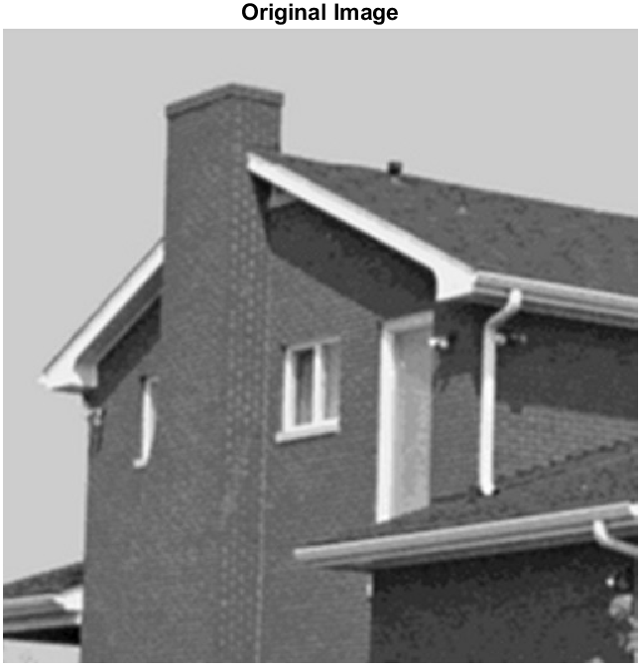 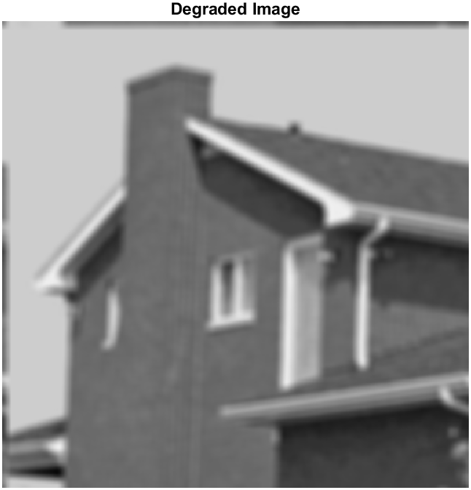

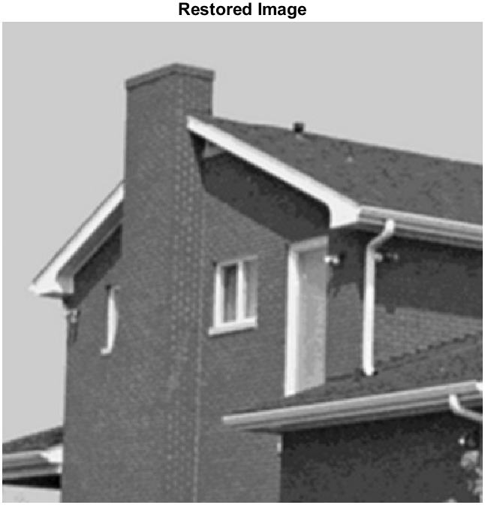

3.Weiner Filter

**%Name: Sanika Sandip Firke**

**% Roll No:31134**

x= imread("C:\Users\kulso\Desktop\pepper.jpeg");

x=double(rgb2gray(x));

sigma = 50;

gamma = 1;

alpha = 1;% It indicates Wiener filter

[M N]=size(x);

h = ones(5,5)/25;

Freqa = fft2(x);

Freqh = fft2(h,M,N);

y = real(ifft2(Freqh.*Freqa))+25*randn(M,N);

Freqy = fft2(y);

Powy = abs(Freqy).^2/(M*N);

sFreqh = Freqh.*(abs(Freqh)>0)+1/gamma*(abs(Freqh)==0);

iFreqh = 1./sFreqh;

iFreqh = iFreqh.*(abs(Freqh)*gamma>1)...

+gamma*abs(sFreqh).*iFreqh.*(abs(sFreqh)*gamma<=1);

Powy = Powy.*(Powy>sigma^2)+sigma^2*(Powy<=sigma^2);

Freqg = iFreqh.*(Powy-sigma^2)./(Powy-(1-alpha)*sigma^2);

ResFreqa = Freqg.*Freqy;

Resa = real(ifft2(ResFreqa));

imshow(uint8(x)),title('Original Image')

figure,imshow(uint8(y)),title('Degraded Image')

figure,imshow(uint8(Resa)),title('Restored Image')

**OUTPUT:**

